1.Intro and Research Background

1.1 Research Background

The intergenerational transmission of socioeconomic status (SES) is a central theme in social stratification and mobility research. A fundamental question in this field is whether an individual's career success is a result of their own merit (educational attainment) or a reflection of their "ascribed" characteristics, such as family background. In modern societies, while education is often viewed as the primary engine for social mobility, empirical evidence suggests that the "long shadow" of the family still plays a decisive role in shaping the career trajectories of the next generation.

In the context of contemporary China, this issue is particularly salient. Over the past few decades, China has experienced rapid economic transformation and a massive expansion of its higher education system. While these changes have created more opportunities for upward mobility, they have also reshaped the mechanisms through which parents pass on their advantages to their children. The persistent divide between rural and urban areas, coupled with the rising importance of social and cultural capital, has made the link between parental SES and children’s occupational outcomes more complex and multifaceted.

1.2 The Research Problem

Despite the growing body of literature on status attainment, several gaps remain. First, how do different dimensions of parental SES—such as education, occupational prestige (ISEI), and family income—interact to influence a child's career choice? Second, in a transitioning economy like China, does the family's economic capital (income) outweigh their cultural capital (education) in securing high-status jobs for their children?

This study utilizes data from the China Family Panel Studies (CFPS) to examine the impact of parental SES on children’s occupational choices. By analyzing variables such as maternal and paternal education, family income, and parental ISEI, we aim to quantify the extent of intergenerational persistence. Specifically, we investigate how parental resources facilitate children's entry into high-prestige occupations and whether this influence varies across gender and residential (rural/urban) lines.

1.3 Research Flowchart

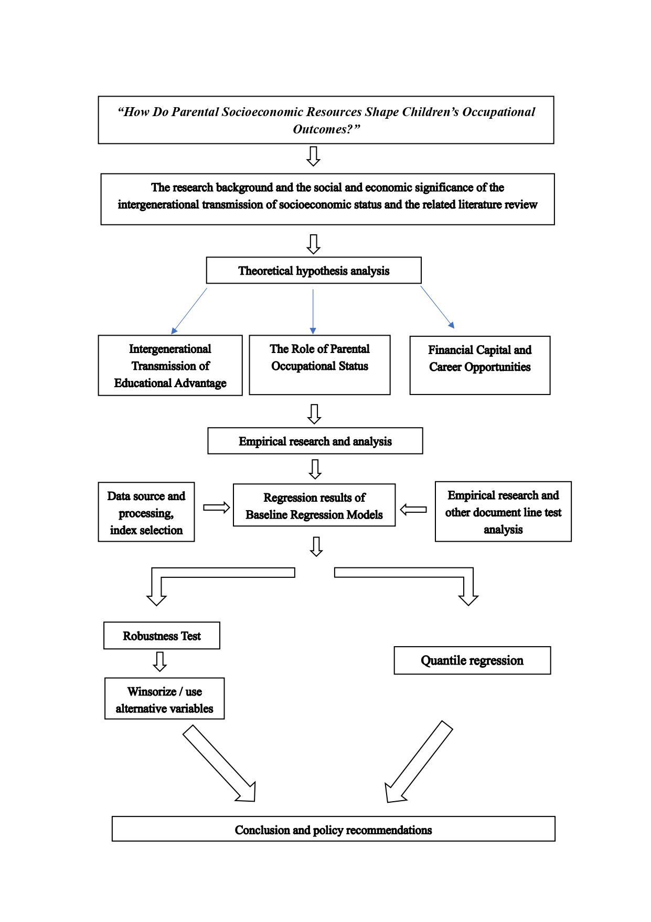

- Literature Review

  - Intergenerational Advantage and Distributional Heterogeneity
The intergenerational transmission of economic advantage has been a central concern in social science research, with scholars examining how parental wealth shapes children's educational attainment, labor market outcomes, and health across the life course. Recent advances in quantile regression methods have enabled researchers to uncover heterogeneous effects that vary across the outcome distribution, revealing that parental resources may amplify advantages particularly at the upper tail of children's achievement distributions.

  - Human Capital Theory and Intergenerational Mobility
Human capital theory and intergenerational mobility provide the foundational framework for understanding parental wealth effects. Araki (2025) demonstrates that education enhances productivity and leads to better labor market performance, traditionally captured by the Mincer earnings function relating years of schooling to wages (Social Science & Medicine, 381, p. 2). This framework is particularly relevant when considering how parental wealth enables educational investments. The quantile regression analysis in Araki's study reveals substantial heterogeneity in returns to college completion across the wage distribution, with direct effects at age 40 ranging from 0.26 at the mean to 0.64 at the 90th percentile (p. 7), suggesting that children from wealthier families who reach higher education levels experience disproportionately larger economic returns.

  - The Education–Health Gradient and Cultural Health Capital
The education-health gradient represents a critical pathway through which parental wealth influences children's long-term well-being. The literature presents mixed evidence on causal effects of education on health outcomes. As documented in the comprehensive review, studies using compulsory schooling reforms as natural experiments show divergent findings: while Gathmann, Jürges, and Reinhold (2015) found positive effects on mortality across twentieth-century Europe, other studies including Arendt (2005) for Denmark, Albouy and Lequien (2009) for France, and Meghir et al. (2018) for Sweden found no causal effect (Education and Adult Health, 2020, p. 3). This inconsistency suggests that the education-health relationship may be contingent on institutional contexts and family resources. Hamad et al. (2018) conducted a systematic review and meta-analysis specifically examining studies of compulsory schooling laws, finding that methodological differences and contextual factors explain much of the disagreement in the literature (p. 168-178). The concept of "cultural health capital" introduced by Dubbin, Chang, and Shim (2013) further illuminates how parental socioeconomic status shapes health-related resources and patient-provider interactions (Social Science & Medicine, 93, p. 113-120), indicating that wealth effects extend beyond financial resources to include social and cultural competencies.

  - Quantile Regression and RIF Regressions
Quantile regression methodology has emerged as essential for capturing the distributional heterogeneity in parental wealth effects. Firpo, Fortin, and Lemieux (2018) developed recentered influence function (RIF) regressions for decomposing wage distributions, enabling researchers to estimate effects at different quantiles rather than relying solely on mean effects (Econometrics, 6(2), p. 1-40). Araki (2025) applies this methodology to demonstrate that both direct and indirect effects of education on wages vary substantially across quantiles, with the ratio of indirect (health-mediated) to total effects being larger at higher quantiles (Q90) than at lower quantiles (Q10). This finding implies that children from wealthy families who achieve higher education not only earn more directly but also benefit more from health-related productivity advantages, creating a compounding effect of initial family wealth.

2.5. Labor Market Mechanisms
SkilLls, tasks, and technological change shape how parental investments translate into labor market returns. The literature emphasizes that task measures collected at the individual worker level offer substantial additional explanatory power for wages relative to occupation-level data. Studies using the German IAB/BIBB survey, including work by Spitz-Oener (2006), Dustmann et al. (2009), and Gathmann and Schönberg (2010), demonstrate that individual task measures provide crucial insights into skill formation and wage determination (Skills, Tasks and Technologies, p. 36). Autor and Handel (2009) similarly show that individual task measures from the PDII survey instrument offer substantial additional explanatory power for wages relative to occupation-level data. This research suggests that parental wealth may influence not just educational credentials but also the specific skills and tasks children are able to develop and deploy in the labor market, with implications for understanding inequality reproduction across generations.

  - New Challenges to Mobility
Emerging health disparities and generational decline present concerning trends for intergenerational mobility. Zheng, Dirlam, Choi, and George (2023) documented the health decline of Americans from baby boomers to millennials, suggesting deteriorating intergenerational outcomes despite rising educational attainment (Social Science & Medicine, 337, article 116282). Zheng, Lu, and Yao (2024) identified emerging health disparities specifically among college graduates, highlighting education-occupation mismatch as a mechanism that may undermine the health benefits traditionally associated with higher education (Social Science Research, 120, article 103015). These findings raise important questions about whether parental wealth can continue to buffer children against broader societal trends of declining health and economic security. The work by Easterlin and colleagues (1990, 1993) on baby boomer economic well-being provides historical context, showing that even advantaged cohorts may face challenges in matching their parents' economic status when entering labor markets during periods of structural change (Journal of Population Economics, 3(4), p. 277-290; Population and Development Review, 19(3), p. 497-522).

  - Causal Inference in Wealth-Education-Health Links
Methodological considerations and causal identification remain central challenges in this literature. The heterogeneity in findings regarding education's causal effect on health underscores the difficulty of isolating parental wealth effects from confounding factors. Studies using twin data, such as Fujiwara and Kawachi (2009), Amin et al. (2015), and Sudharsanan et al. (2016), generally find small or no effects of education on health, suggesting that family background factors shared by twins may be more important than educational differences per se (Education and Adult Health, 2020, p. 3). This implies that observed correlations between parental wealth, children's education, and children's outcomes may partly reflect genetic or family environmental factors rather than purely causal effects of wealth-enabled investments. The application of quantile regression methods helps address this concern by revealing whether effects are concentrated at particular points in the outcome distribution where selection effects might be less severe.

  - Bibliometric Research

Furthermore, this study also employed a bibliometric approach to examine the research landscape of social mobility. The data were collected from the Web of Science Core Collection (WoSCC). The search was conducted using the query TS = ("social mobility" OR "intergenerational mobility"). In WoS, TS refers to Topic Search, which covers the title, abstract, author keywords, and Keywords Plus.

Figure 1 shows the top 10 most frequent keywords in the dataset. Social mobility is the most frequent keyword, followed by education and intergenerational mobility. This indicates that the field is primarily concerned with mobility processes, educational factors, and intergenerational transmission. Other frequently occurring keywords, such as family background, social stratification, educational attainment, and occupational attainment, suggest that the literature is closely related to inequality, class reproduction, and status attainment.
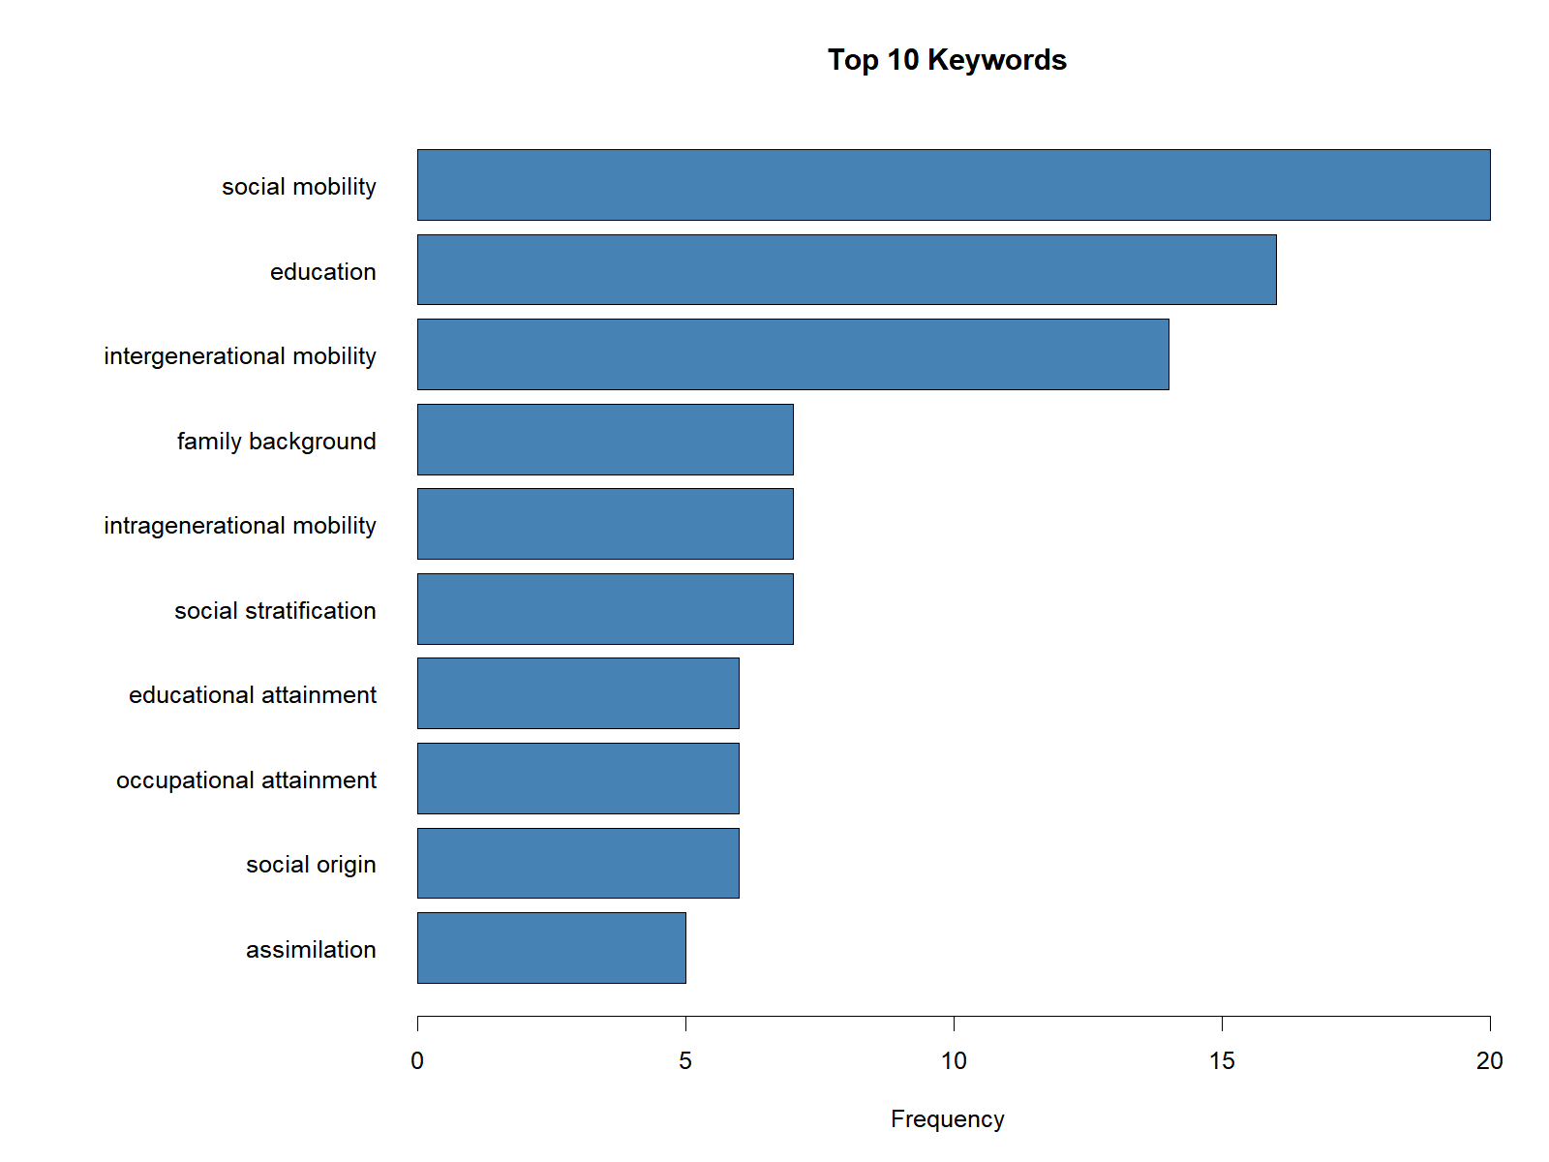
Figure 2 presents the keyword co-occurrence network. The largest nodes, including inequality, social mobility, attainment, and united-states, occupy central positions in the network, indicating their importance in the field. The network also shows strong connections among family background, education, occupational attainment, and intergenerational mobility, suggesting that these topics form the core conceptual structure of the literature. In addition, keywords such as childhood, children, earnings, and work indicate a related focus on life-course outcomes and labor market consequences.

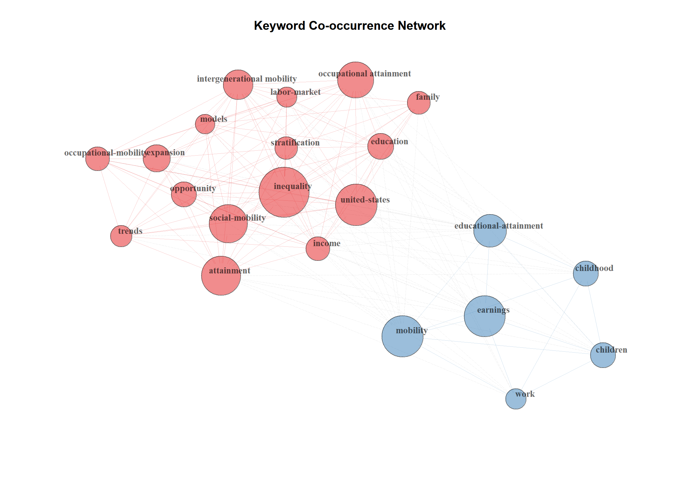
Figure 3 illustrates the country collaboration network. The United States is the most central and influential country in the network, with strong collaborative ties to the United Kingdom, Germany, and Sweden. This suggests that the field is largely dominated by the United States and several European countries. Although other countries, such as Canada, the Netherlands, Finland, China, and Switzerland, also participate in international collaboration, their positions are relatively less central. Overall, the network reveals an uneven but active pattern of global academic cooperation.
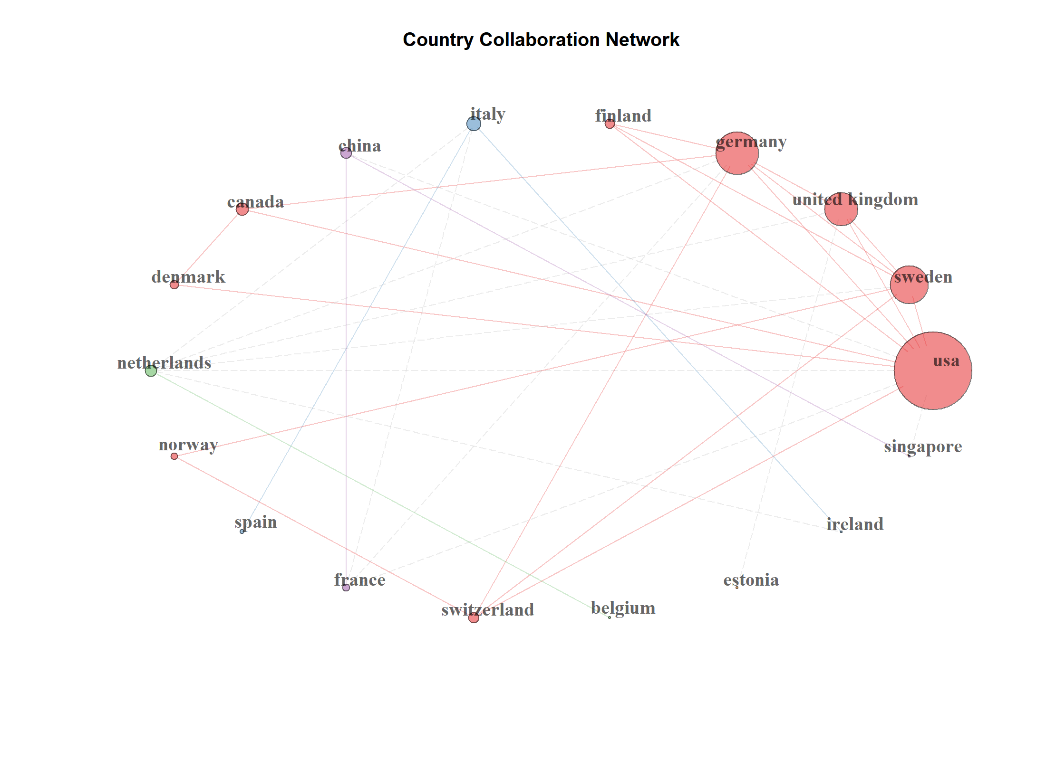

Figure 4 presents the thematic structure of the field. Intergenerational mobility appears in the motor-theme area, indicating that it is both important and relatively well developed. Social mobility and family background are located in the basic-theme area, showing that they are central to the field but remain broad and foundational topics. Education and higher education are positioned in the niche-theme area, suggesting that they are internally developed but less central to the overall field. Inequalities appears in the emerging or declining theme area, indicating that it is either still developing or less consolidated in the current sample.

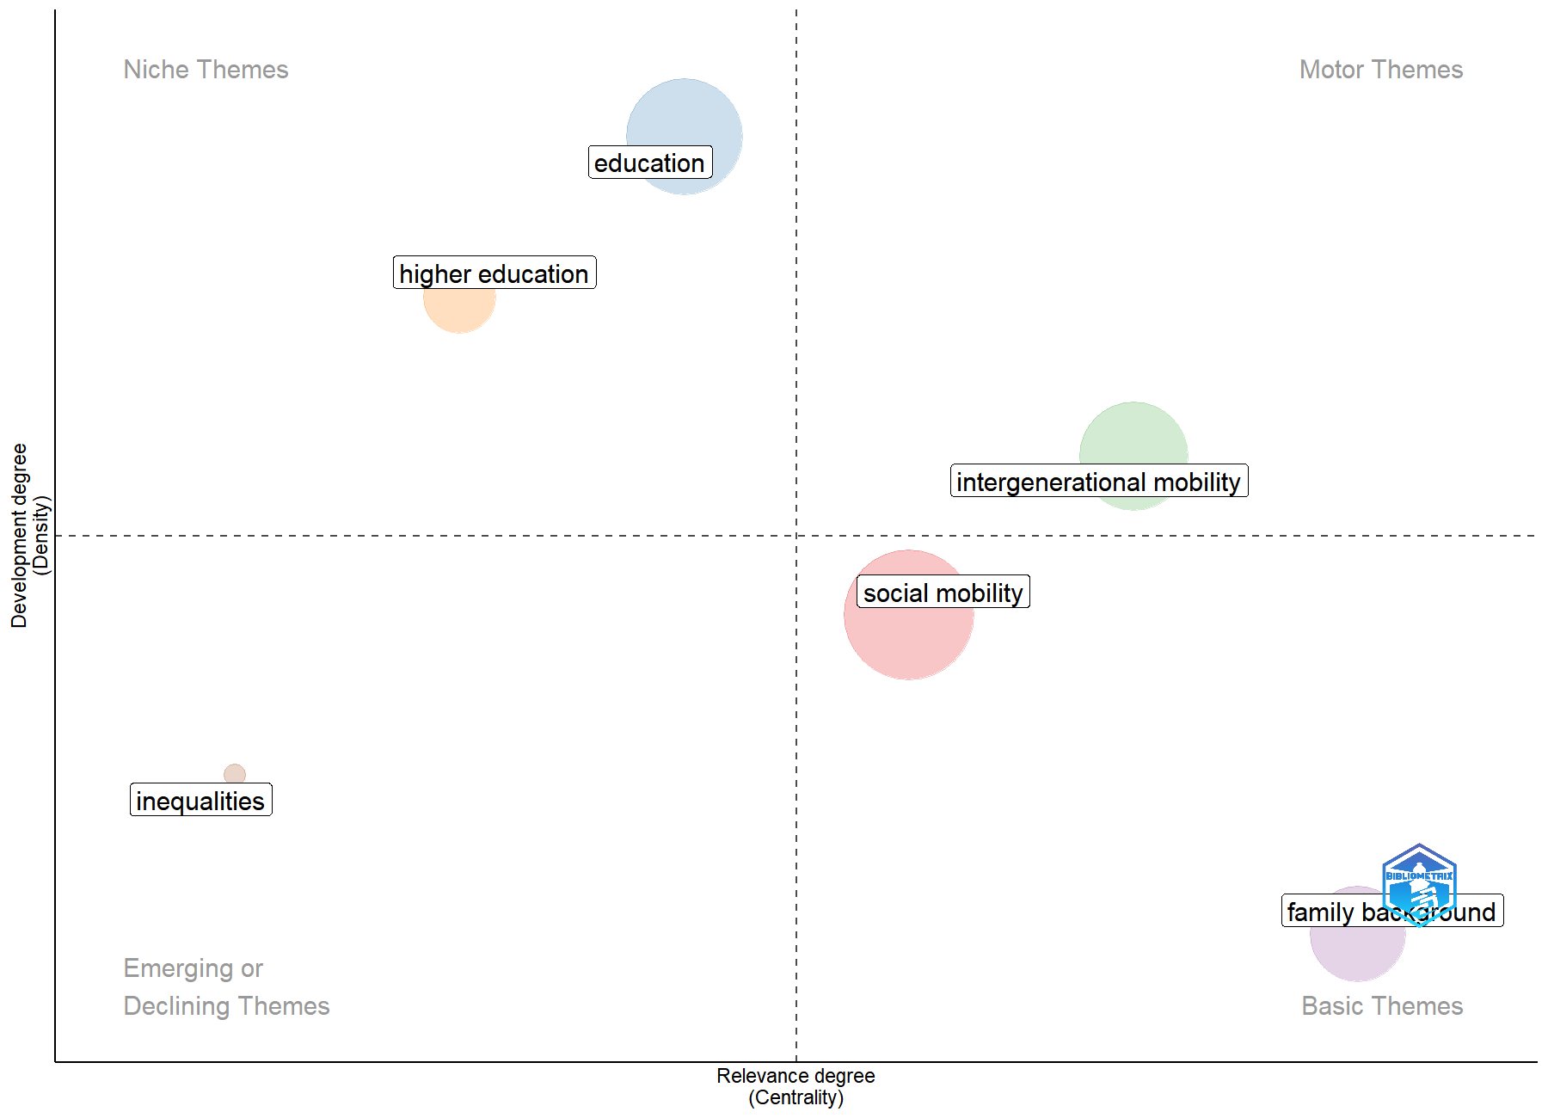

Overall, the bibliometric results show that the literature on social mobility is mainly structured around education, family background, inequality, and intergenerational mobility. The field is supported by active international collaboration, although research output is concentrated in a limited number of countries, especially the United States and Western Europe. These findings suggest that social mobility research continues to focus on how structural inequality and family-related factors shape educational, occupational, and life-course outcomes.

3.Theory and Hypothesis

This study is grounded in theories of intergenerational mobility, human capital accumulation, and social stratification, which emphasize the persistence of socioeconomic advantage across generations. Parents influence their children’s labor-market outcomes through multiple, interrelated channels, including educational investment, occupational role modeling, and the provision of financial and social resources. These mechanisms jointly shape children’s skill formation, educational trajectories, and eventual occupational attainment.

3.1 Intergenerational Transmission of Educational Advantage

Education constitutes a central mechanism through which socioeconomic status is transmitted across generations. According to human capital theory, parental education enhances children’s cognitive and non-cognitive skill development by shaping early learning environments, educational aspirations, and academic support. Highly educated parents are more likely to possess the cultural capital necessary to navigate educational institutions, transmit effective learning strategies, and set higher expectations for academic achievement. These advantages translate into greater educational attainment for children, which in turn increases access to high-status occupations.

Moreover, education not only improves formal qualifications but also fosters problem-solving abilities, communication skills, and adaptability—traits that are increasingly rewarded in modern labor markets. Consequently, children from more educated families are better positioned to sort into occupations with higher prestige and socioeconomic status.

Hypothesis 1 (Educational Transmission):
Parental educational attainment has a significant and positive effect on children’s occupational outcomes.

3.2 Parental Occupational Status and Social Capital

Beyond education, parental occupational status reflects accumulated labor-market advantages such as professional reputation, workplace experience, and access to valuable social networks. Parents employed in high-status occupations are more likely to transmit occupation-specific knowledge, provide career-related information, and facilitate entry into prestigious professions through referrals and informal connections. These forms of social capital are particularly important in labor markets where hiring practices rely on networks and reputation rather than purely formal credentials.

In addition, children may internalize occupational norms and aspirations through parental role modeling, shaping their career expectations and job search behavior. Parental occupational status therefore influences not only opportunities but also preferences, reinforcing intergenerational persistence in occupational stratification.

Hypothesis 2 (Occupational Status Transmission):
Parental occupational status, measured by ISEI, is positively associated with the prestige of children’s occupational outcomes.

3.3 Financial Capital and Career Opportunities

Family income represents a critical resource that relaxes budget constraints over the life course. Higher-income households can invest more in children’s education through better schooling, tutoring, extracurricular activities, and geographic mobility. Financial resources also reduce children’s exposure to economic uncertainty, allowing them to pursue longer educational pathways, accept unpaid or low-paid internships, and delay labor-market entry in favor of skill accumulation.

From a life-cycle perspective, credit constraints disproportionately affect children from low-income families, forcing earlier labor-market participation and limiting access to high-return educational investments. As a result, family income plays an independent role in shaping occupational outcomes, even after accounting for parental education and occupational status.

Hypothesis 3 (Financial Capital Effect):
Higher family income is associated with more favorable occupational outcomes for children.

4. Data

4.1 Sample Construction

This study uses data from the China Family Panel Studies (CFPS) for the years 2010, 2012, 2014, 2016, 2018, 2020, and 2022. The CFPS is a nationally representative longitudinal survey that collects rich information on individuals, households, education, employment, income, and family relations, making it particularly suitable for studying intergenerational socioeconomic transmission.

The unit of analysis in this paper is the child generation, while parental information is linked to each child through parent identifiers available in the CFPS. Because the naming conventions and linkage structure vary across waves, a standardized cross-wave dataset was first constructed. In particular, father and mother identifiers were harmonized using wave-specific parent linkage variables. The 2016 wave required additional matching through the family relationship file, while the 2020 and 2022 waves used revised parent identifiers. This harmonization process allows us to build comparable child-parent matched observations across all survey years.

The final analytical dataset combines individual-level information on children’s occupational outcomes with parental background characteristics. The core outcome variable is the child’s occupational status measured by the International Socio-Economic Index (ISEI). The main explanatory variables capture parental socioeconomic status through occupational status, educational attainment, and political affiliation. In addition, a range of child-level controls, including gender, age, and urban residence status, are incorporated into the regression analysis.

Although CFPS is designed as a panel survey, the availability of complete occupational and parental information differs by wave. Therefore, the empirical analysis in this paper is based on a pooled multi-wave matched sample with year-specific regressions, rather than a strictly balanced panel. This strategy preserves the largest possible number of valid observations while allowing us to compare the strength of intergenerational transmission across survey years.

4.2 Variable Construction

4.2.1. Dependent Variable

The dependent variable is child occupational status, measured by child ISEI. The ISEI is a widely used continuous indicator of occupational socioeconomic standing and is especially appropriate for research on status attainment and intergenerational mobility.

For the 2016–2022 waves, the ISEI measure is directly available from the occupational coding system in CFPS. For 2012 and 2014, occupational information was first harmonized from five-digit occupation codes and then converted into internationally comparable status indicators. For 2010, the corresponding occupational status variable is directly available in the survey.
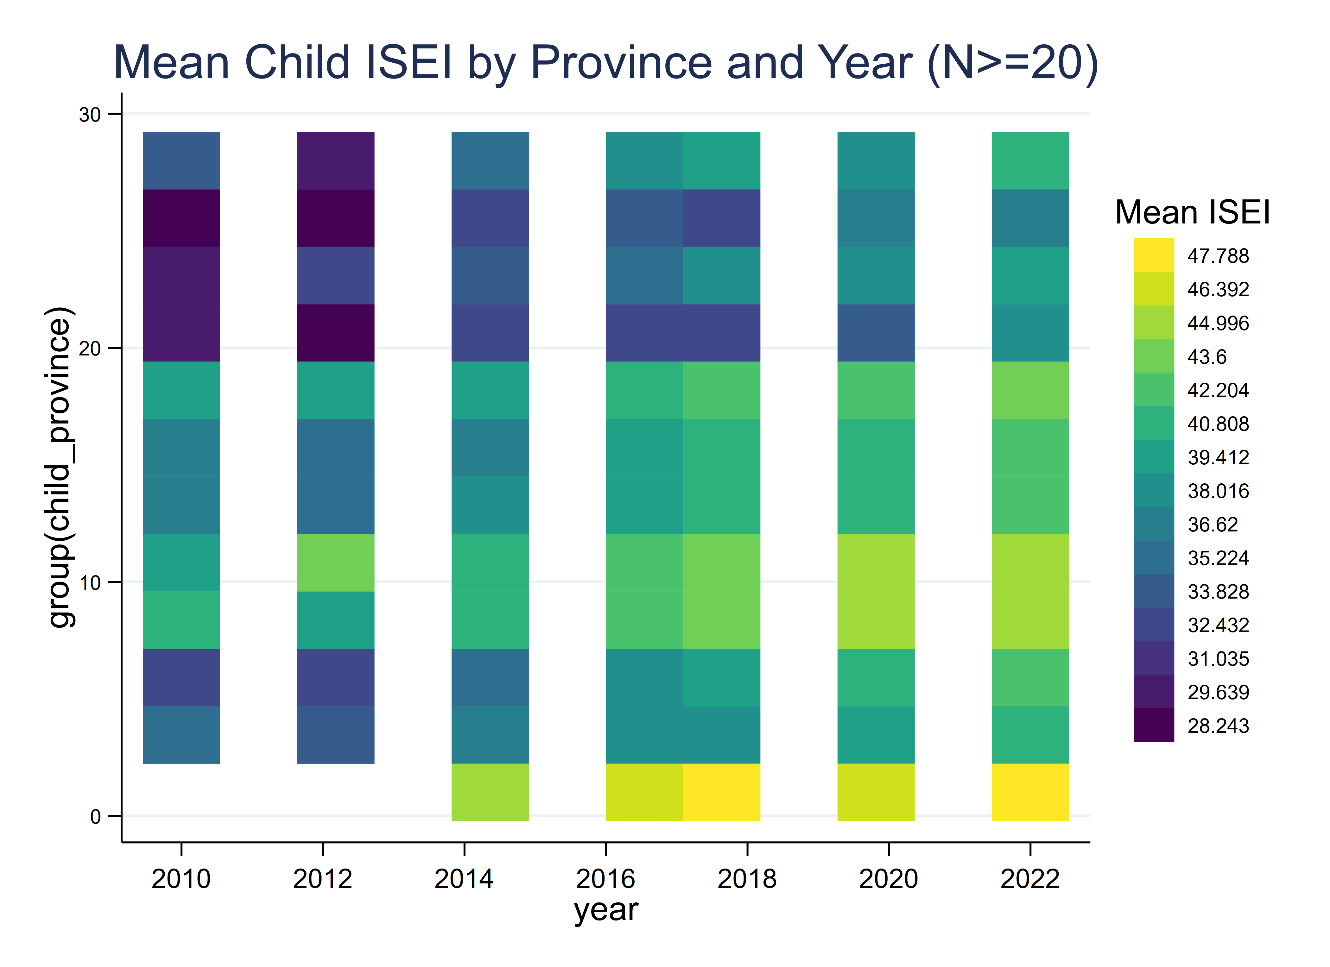
The use of ISEI has two advantages. First, it provides a continuous measure of occupational attainment, which is more informative than broad categorical class schemes. Second, it allows direct comparison of occupational status across different years after harmonization.

4.2.2. Core Independent Variables: Parental Socio-Economic Status

The main independent variable is parental socioeconomic status (SES), constructed as a composite measure using principal component analysis (PCA). Specifically, the PCA index combines the following five parental characteristics. The first principal component is extracted separately by survey year and used as the summary measure of parental SES, denoted as parent_ses_pca. This procedure captures the common variation in parental occupational, educational, and political resources, thereby providing a multidimensional indicator of family background.

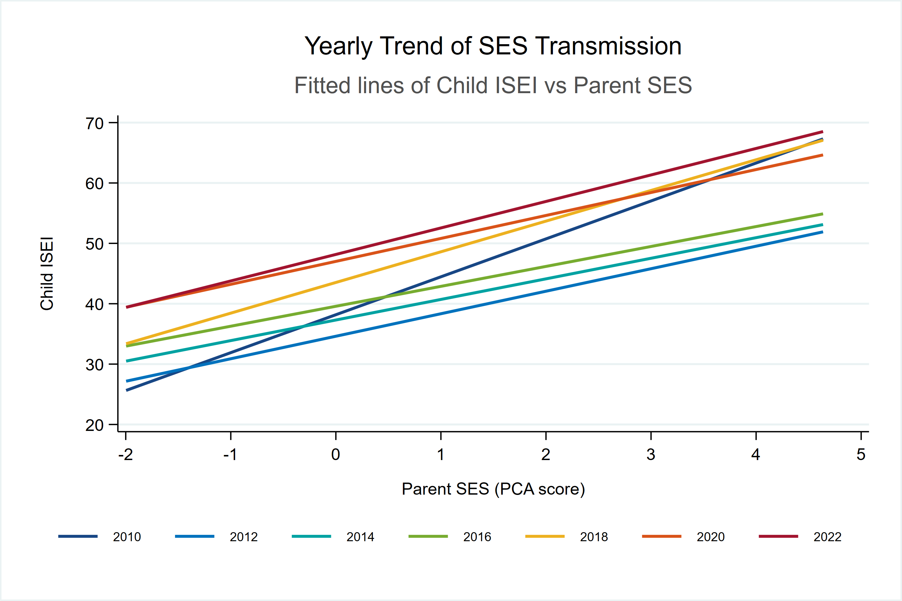

Using PCA has both conceptual and empirical advantages. Conceptually, parental SES is inherently multidimensional and cannot be fully represented by a single characteristic such as income or education alone. Empirically, PCA reduces dimensionality and mitigates multicollinearity among correlated parental background variables.

4.2.3. Control Variables

We include a rich set of individual and household-level control variables. At the child level, these include age, gender (coded as a binary variable), and residential status (urban versus rural). At the household level, we control for province of residence to capture regional heterogeneity. All regressions additionally include province fixed effects and year fixed effects, which absorb time-invariant regional characteristics and common macroeconomic shocks.

4.3 Data Cleaning and Sample Selection

Given substantial variation in questionnaire design and variable coding across CFPS waves, extensive data cleaning and harmonization were required before conducting the empirical analysis.

First, variable names were standardized across waves so that equivalent concepts could be consistently identified. This was especially important for demographic characteristics, income, education, marital status, occupational codes, and family identifiers. Several variables also required wave-specific recoding because the original questionnaire wording or coding frame changed over time.

Second, observations with invalid or non-comparable values were removed. In CFPS, negative values often indicate item nonresponse, refusal, or inapplicability rather than true numerical values. Therefore, such observations were dropped for variables where negative responses clearly represented invalid codes. For example, children’s years of education, income, educational expectations, marital status, internet use, sleep duration, subjective rankings, life satisfaction, future confidence, tutoring participation, boarding status, and several behavioral indicators were cleaned using this rule whenever relevant.

Third, occupational measures were harmonized carefully. The 2012 and 2014 waves required special processing because occupational status indicators were not directly reported in the same form as in later years. In these waves, five-digit occupation codes were converted into internationally comparable measures such as ISCO, ISEI, SIOPS, and EGP using standardized conversion procedures. This step is crucial for ensuring consistency in the dependent variable across survey years.

Fourth, parental matching was implemented using father and mother identifiers. Because parent-child links are not completely identical across waves, special treatment was required in some years. In particular, the 2016 wave relied on an additional family configuration file to recover father and mother identifiers, while the 2020 and 2022 waves used revised parent-link variables. After matching, observations were retained only when the child could be linked to at least one parent with valid information on the relevant SES components.

Finally, the regression sample was restricted to observations with non-missing values for the dependent variable, the key explanatory variable(s), and the control variables. Because the PCA index is constructed from multiple parental characteristics, the effective sample size for the baseline specification is smaller than the raw survey sample and varies considerably across years. This explains the relatively small sample size in some waves, especially 2010, where complete child-parent matched occupational information is much more limited.

Overall, the final dataset is a cleaned and harmonized multi-wave child-parent matched sample suitable for examining the evolution of intergenerational occupational status transmission in China.

- Empirical Results

5.1. Satistical Discription

Table 1 reports the mean values of the main variables by survey year from 2010 to 2022. Several notable patterns emerge from the descriptive evidence.
First, the average level of children’s occupational status, measured by ISEI, shows a clear upward trend over time. The mean value of child ISEI increases from 36.29 in 2010 to 41.56 in 2022. A similar pattern is observed for child SIOPS, which rises from 40.22 to 41.38, while the mean of child EGP declines from 6.99 to 5.59, consistent with a movement toward relatively higher-status occupational categories under the coding scheme used in the data. The boxplot of child ISEI by year further shows that the median and upper quartiles shift upward over time, indicating an overall improvement in occupational attainment among the child generation.

Table 1. Descriptive Statistics
 | Mean | SD | Min | Max | N
Child ISEI | 39.059 | 15.239 | 12.000 | 88.000 | 8095
Parent SES (PCA) | 0.005 | 1.461 | -2.895 | 8.466 | 8095
Father ISEI | 29.927 | 12.671 | 12.000 | 88.000 | 8095
Mother ISEI | 27.657 | 10.717 | 12.000 | 88.000 | 8095
Father education | 7.293 | 4.172 | 0.000 | 19.000 | 8095
Mother education | 4.806 | 4.588 | 0.000 | 19.000 | 8095
Any parent CPC | 0.251 | 0.434 | 0.000 | 1.000 | 8095
Male | 0.690 | 0.463 | 0.000 | 1.000 | 8095
Age | 28.045 | 6.645 | 14.000 | 71.000 | 8095
Urban | 0.443 | 0.497 | 0.000 | 1.000 | 8095

Furthermore, the background characteristics of parents also reveal gradual socioeconomic improvement. Fathers’ average ISEI rises slightly from 31.77 to 31.81, while mothers’ average ISEI increases more clearly from 28.46 to 31.04. Parental education also increases over time: fathers’ years of schooling rise from 6.94 in 2010 to 8.47 in 2022, and mothers’ schooling rises from 4.70 to 6.63. These descriptive trends suggest that the socioeconomic resources available to children through family background have improved across successive survey waves.

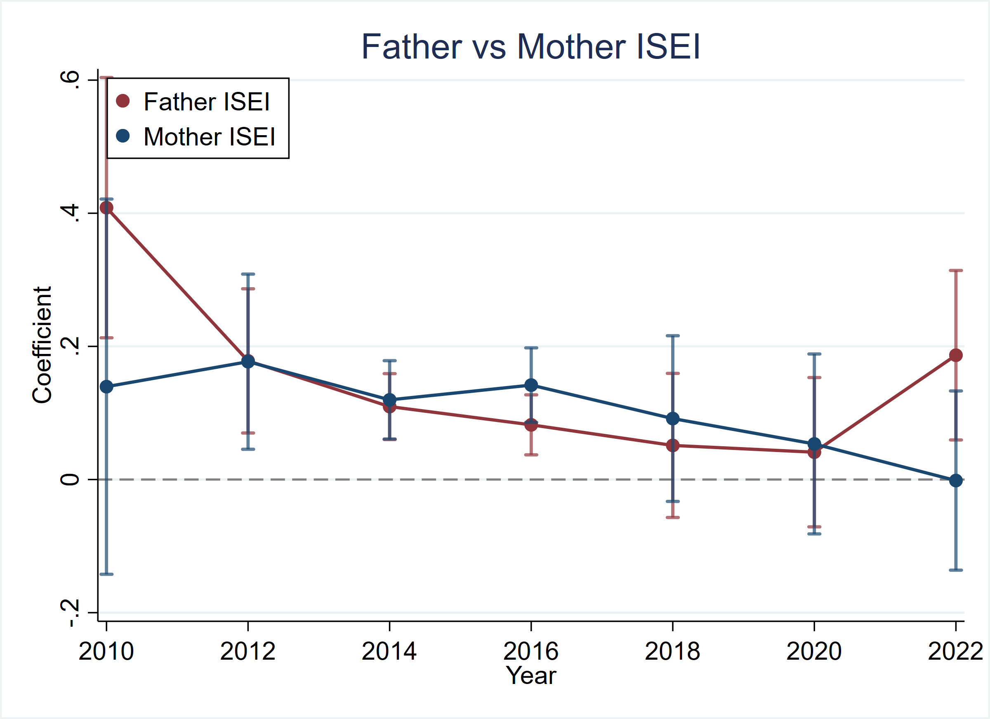

The geographical distribution of children’s occupational status further highlights important spatial inequalities. The provincial maps show that mean child ISEI is generally higher in the more economically developed eastern and southeastern provinces, while lower values are more common in inland and less developed regions. Over time, the maps suggest a broad upward shift in occupational status across many provinces, but regional disparities remain visible. This spatial pattern is consistent with the inclusion of province fixed effects in the regression models.

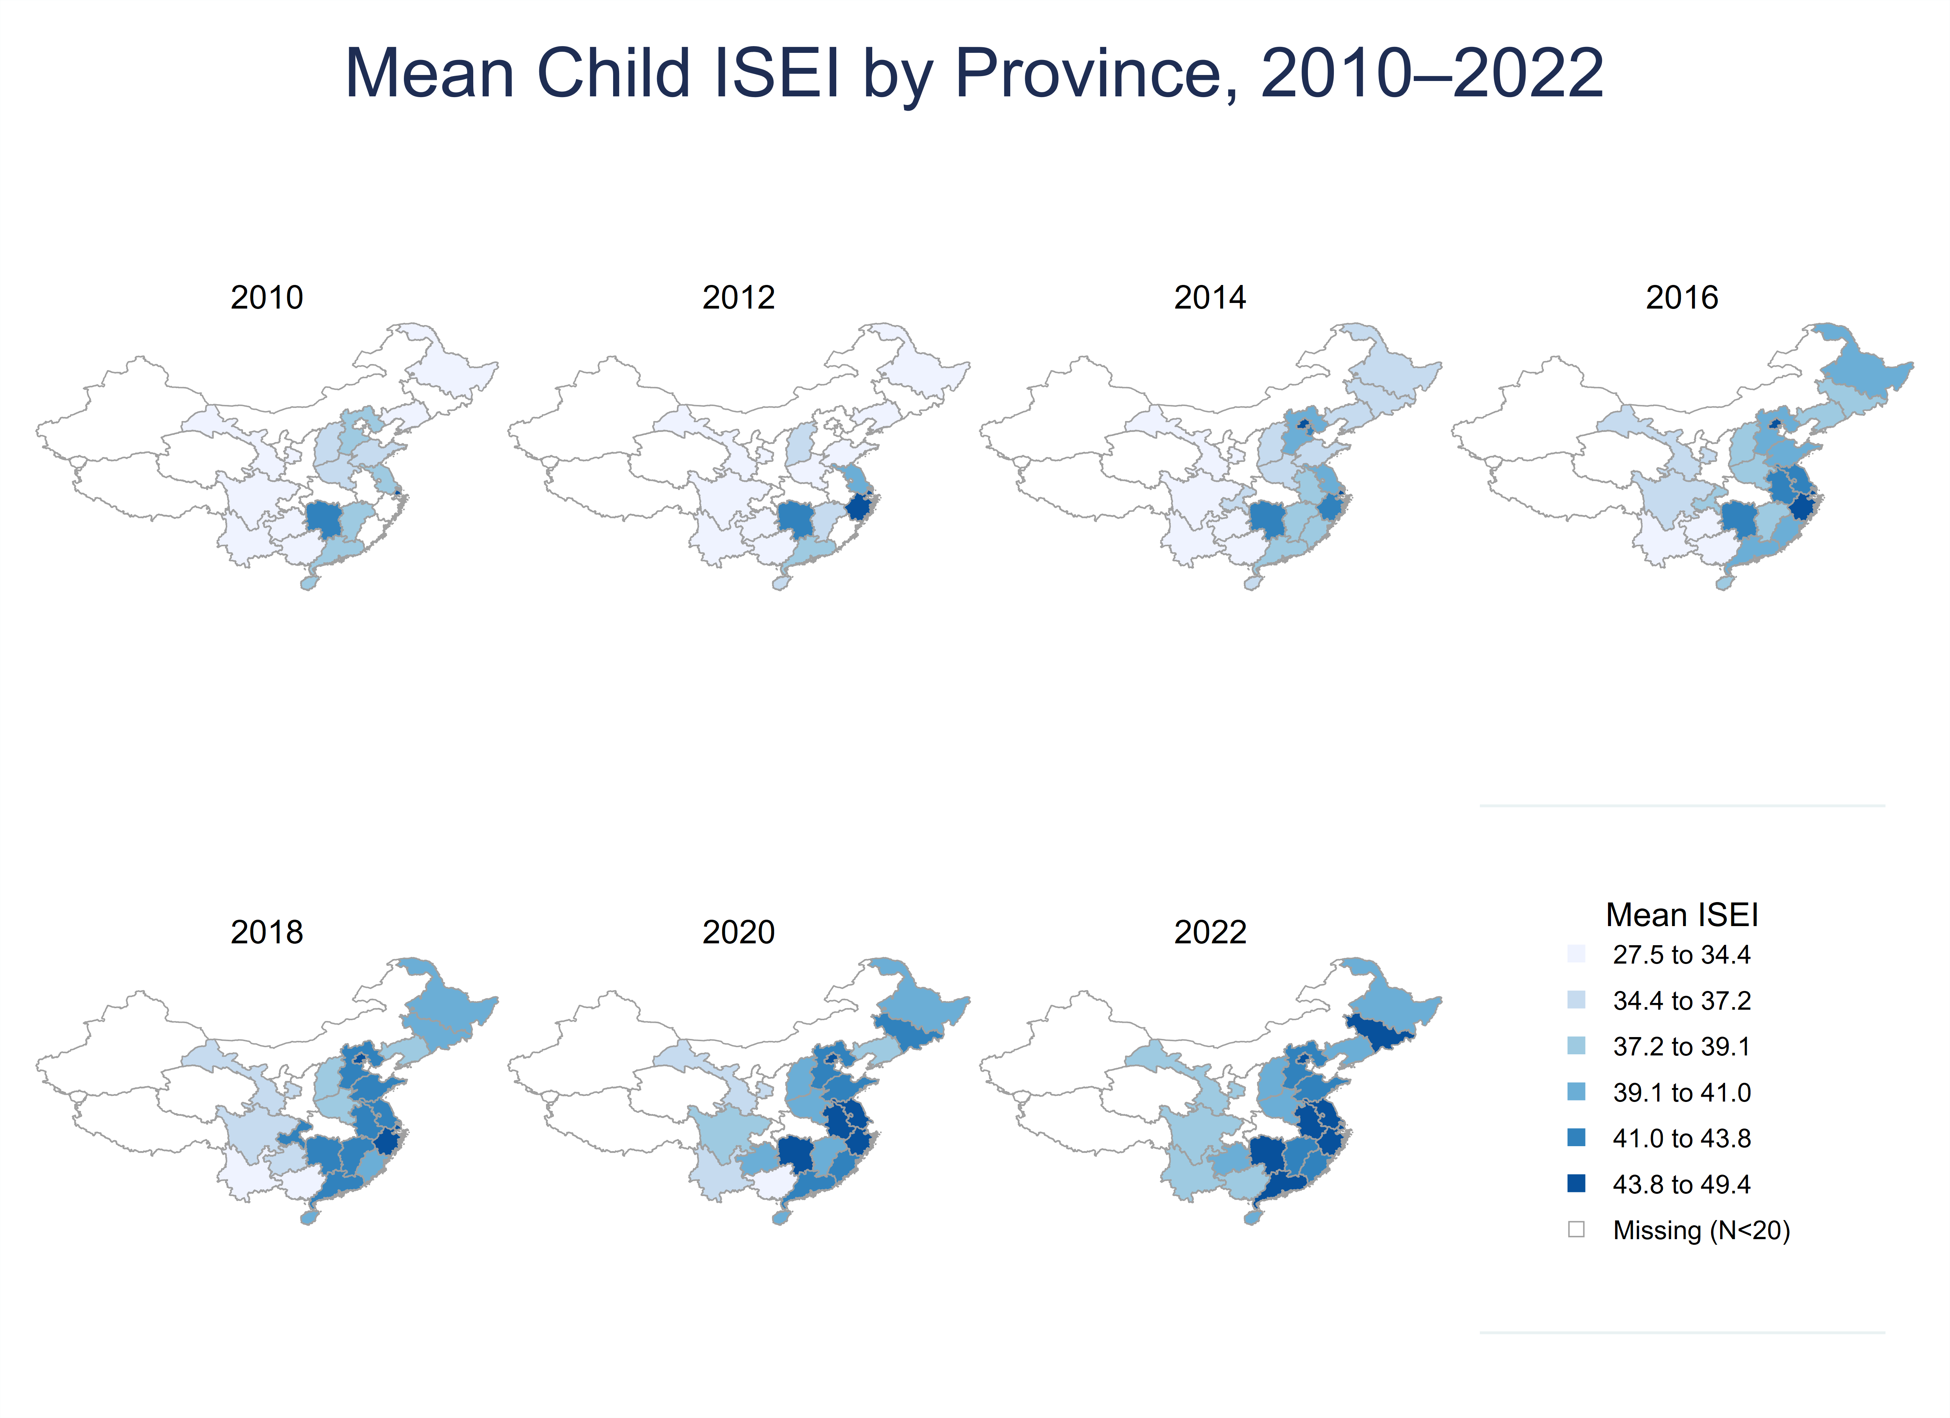

Finally, the scatterplots of child ISEI against parent SES (PCA) reveal a consistently positive association in every survey year. Although there is substantial dispersion in the data, the fitted lines are upward sloping throughout, indicating that children from more advantaged family backgrounds tend to occupy higher-status positions in the occupational hierarchy. The overlaid fitted lines suggest that this positive relationship is persistent across waves, which provides preliminary support for the intergenerational transmission hypothesis examined more formally in the regression analysis.
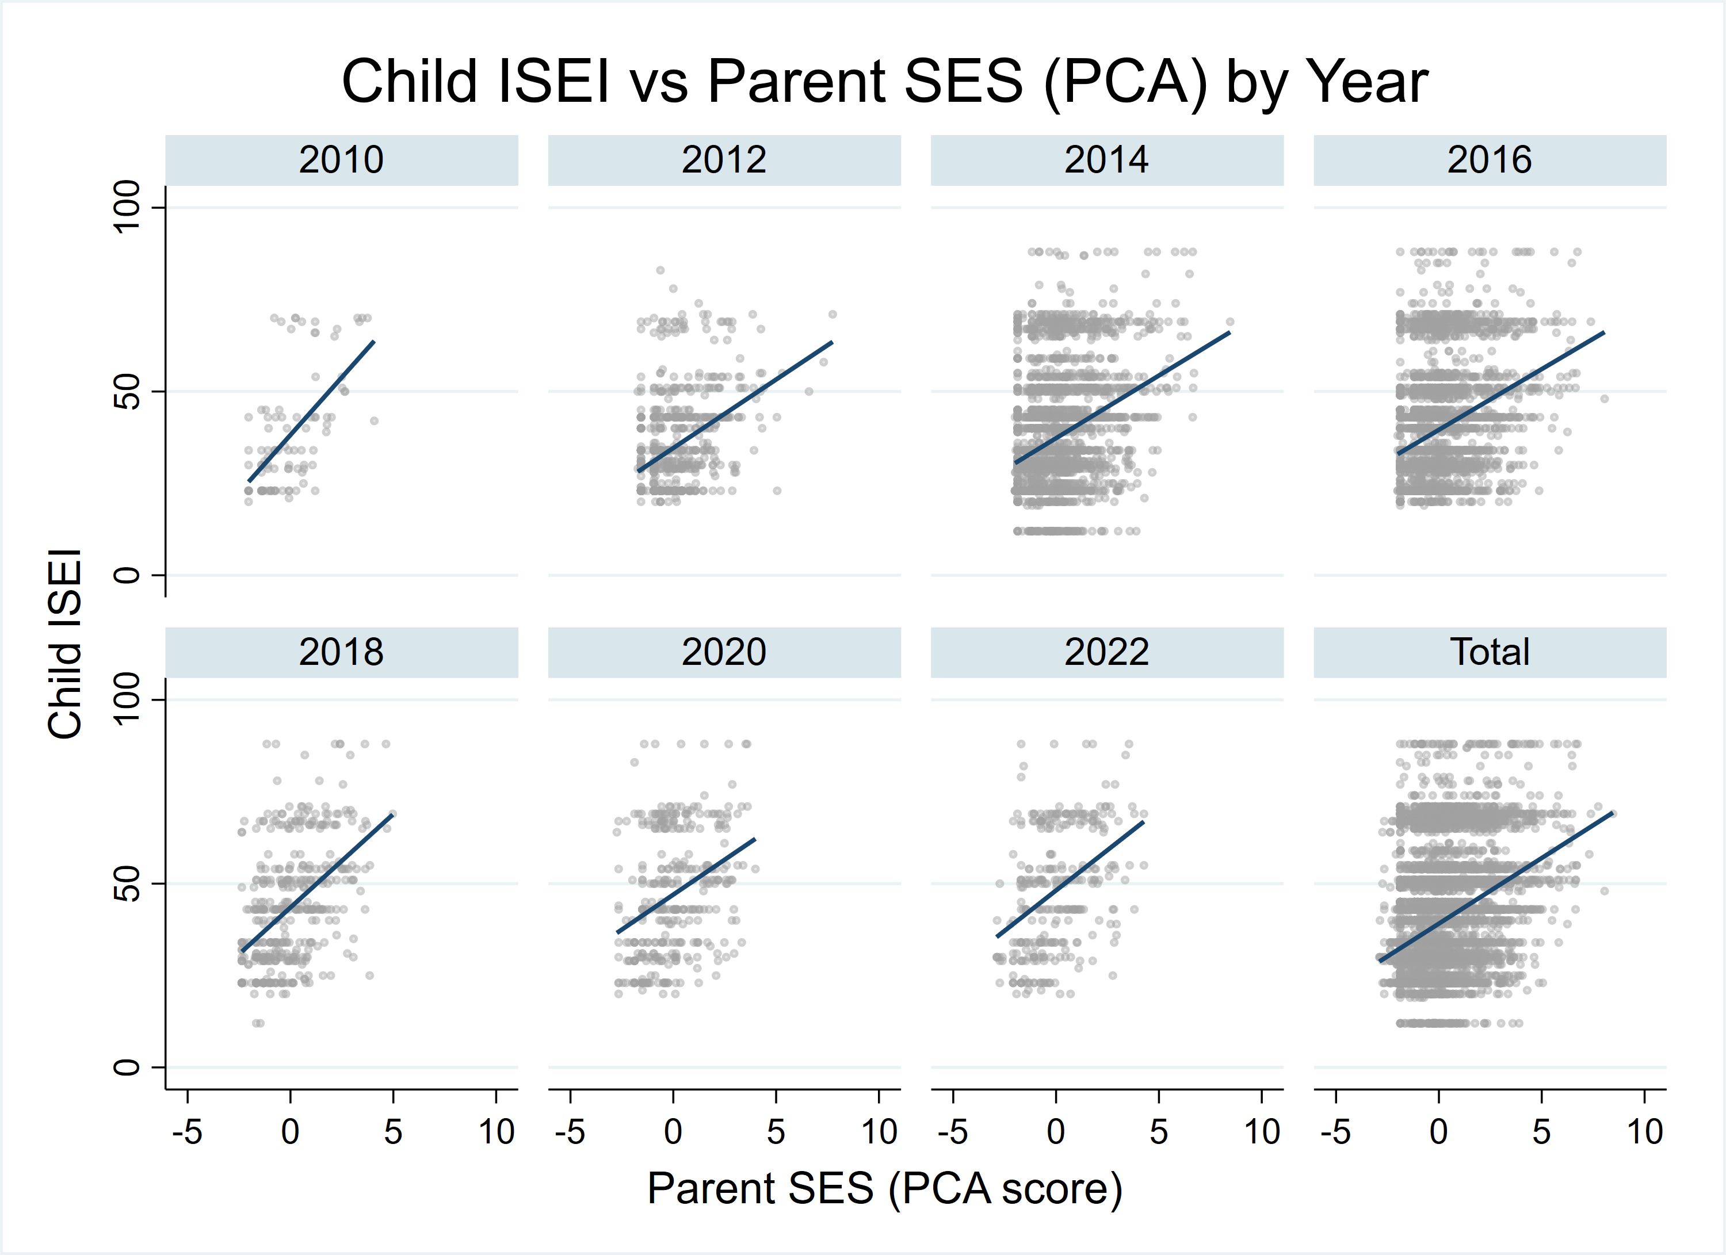

Overall, the descriptive evidence points to three broad conclusions. First, children’s occupational status improved over the 2010–2022 period. Second, parental education and occupational status also rose over time, implying improving family background resources. Third, both the graphical and tabular evidence suggest that family socioeconomic advantage remains positively associated with children’s status attainment, motivating the multivariate analysis that follows.

5.2. Baseline Regression Models



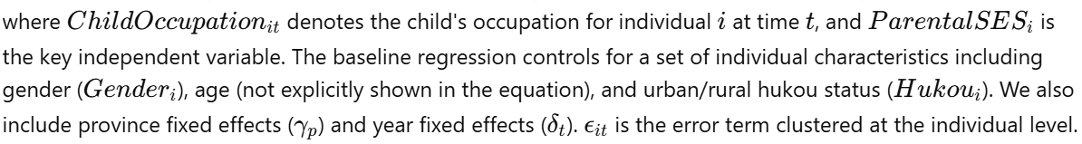
Table 2 reports the yearly regressions of child ISEI on parental SES (PCA). Across all survey waves from 2010 to 2022, the estimated coefficient on parent_ses_pca is positive and statistically significant at the 1 percent level. This finding provides strong evidence that children from families with higher socioeconomic status tend to achieve higher occupational status themselves.

Table 2. Child ISEI on Parent SES (PCA)
 | (1) | (2) | (3) | (4) | (5) | (6) | (7)
 | 2010 | 2012 | 2014 | 2016 | 2018 | 2020 | 2022
parent_ses_pca | 7.252*** | 2.811*** | 2.792*** | 2.507*** | 3.406*** | 2.842*** | 3.006***
 | (1.287) | (0.371) | (0.190) | (0.174) | (0.569) | (0.662) | (0.649)
N | 94 | 680 | 2845 | 3463 | 399 | 313 | 301
r2 | 0.610 | 0.265 | 0.185 | 0.190 | 0.350 | 0.300 | 0.342
Standard errors in parentheses
* p < 0.1, ** p < 0.05, *** p < 0.01

More specifically, the estimated coefficients are 7.252 in 2010, 2.811 in 2012, 2.792 in 2014, 2.507 in 2016, 3.406 in 2018, 2.842 in 2020, and 3.006 in 2022. The consistently positive coefficients suggest that intergenerational status transmission is a stable feature across all observed years. In substantive terms, an increase in the parental SES composite score is associated with a meaningful increase in the child’s occupational ISEI, even after controlling for child gender, age, urban status, and province fixed effects.

At the same time, the magnitude of the coefficient varies across years. From 2012 onward, the coefficient becomes more stable, fluctuating roughly between 2.5 and 3.4. This pattern suggests that parental background continues to exert a persistent and sizeable influence on children’s occupational attainment over time.

The explanatory power of the baseline model is moderate to high. The R-squared ranges from 0.185 in 2014 to 0.610 in 2010. Again, the very high R-squared in 2010 likely reflects the limited sample size and should not be overinterpreted. For the larger samples in 2014 and 2016, the model explains about 19 percent of the variation in child occupational status, while the fit improves in 2018, 2020, and 2022.

Taken together, the PCA-based specification supports the central argument of this paper: parental socioeconomic resources are strongly and positively associated with children’s occupational status attainment. The persistence of this relationship across all seven waves suggests that intergenerational occupational transmission remains an important mechanism of social stratification.

To better understand which aspects of family background matter most, Table 3 reports the regressions in which parental SES is decomposed into its five constituent variables.

Table 3. Child ISEI on Father/Mother SES components
 | (1) | (2) | (3) | (4) | (5) | (6) | (7)
 | 2010 | 2012 | 2014 | 2016 | 2018 | 2020 | 2022
f_isei | 0.408*** | 0.178*** | 0.110*** | 0.082*** | 0.051 | 0.041 | 0.187***
 | (0.100) | (0.055) | (0.025) | (0.023) | (0.055) | (0.057) | (0.065)
m_isei | 0.139 | 0.177*** | 0.120*** | 0.142*** | 0.092 | 0.053 | -0.002
 | (0.144) | (0.067) | (0.030) | (0.029) | (0.064) | (0.069) | (0.069)
f_edu | 1.434*** | 0.183 | 0.428*** | 0.275*** | 0.013 | 0.290 | 0.329
 | (0.419) | (0.120) | (0.073) | (0.066) | (0.223) | (0.288) | (0.296)
m_edu | -0.179 | 0.382*** | 0.297*** | 0.418*** | 0.928*** | 0.567** | 0.314
 | (0.389) | (0.129) | (0.070) | (0.066) | (0.194) | (0.230) | (0.249)
parent_party_any | 0.000 | 1.219 | 2.044*** | 0.614 | 0.000 | 0.000 | 0.000
 | (.) | (1.452) | (0.771) | (0.703) | (.) | (.) | (.)
N | 94 | 680 | 2845 | 3463 | 399 | 313 | 301
r2 | 0.664 | 0.267 | 0.186 | 0.192 | 0.370 | 0.304 | 0.351
Standard errors in parentheses
* p < 0.1, ** p < 0.05, *** p < 0.01

The coefficients on father’s ISEI are positive in every year and statistically significant in most cases. Specifically, father’s ISEI is significant at the 1 percent level in 2010, 2012, 2014, 2016, and 2022, with coefficients ranging from 0.041 to 0.408. The effect is positive but not statistically significant in 2018 and 2020. Overall, these results indicate that fathers’ occupational status is an important predictor of children’s occupational attainment, although the strength of this relationship varies across waves.



The coefficients on mother’s ISEI are also generally positive, but the pattern is less stable. Mother’s ISEI is statistically significant in 2012, 2014, and 2016, but not in 2010, 2018, 2020, or 2022. In 2022, the estimated coefficient is close to zero. Compared with fathers’ occupational status, mothers’ occupational status appears to have a more uneven effect across survey years.

A reasonable interpretation is that occupational transmission remains a key channel of status reproduction, but paternal occupational advantage may be more directly reflected in children’s labor market outcomes in some periods, whereas maternal occupational influence may depend more strongly on cohort composition, labor market conditions, or sample structure.

The effects of parental education also show important heterogeneity. Father’s education has a positive and significant effect in 2010, 2014, and 2016, but is not statistically significant in the other years. In contrast, mother’s education is more consistently associated with child occupational attainment. The coefficient on mother’s education is positive and statistically significant in 2012, 2014, 2016, 2018, and 2020, with especially large estimates in 2018 and 2020.

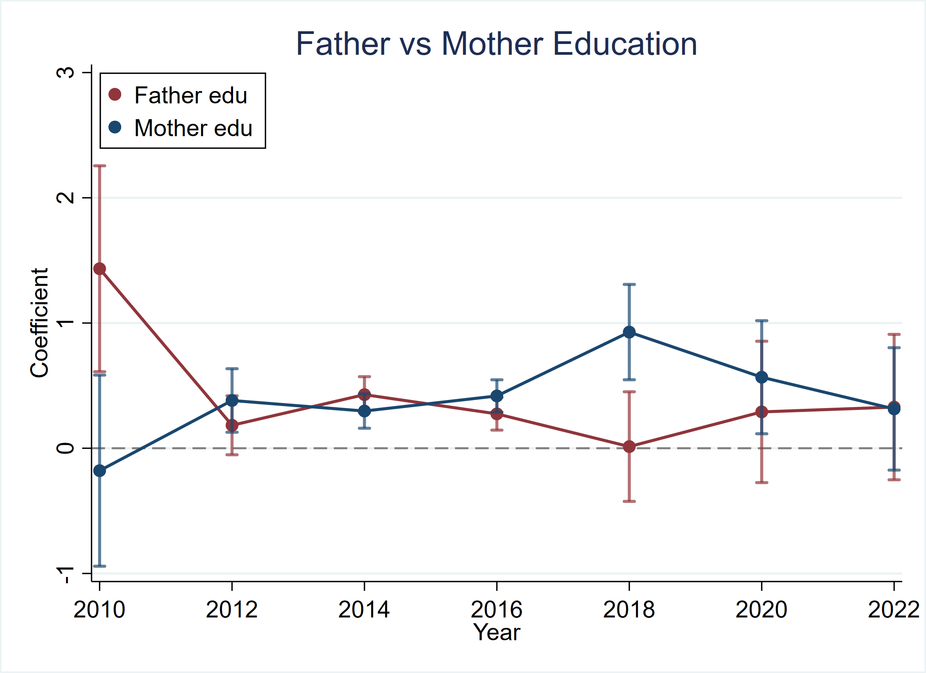

This pattern is noteworthy because it suggests that maternal education may play a particularly important role in shaping children’s long-term status attainment. One possible explanation is that better-educated mothers contribute more strongly to children’s human capital accumulation, educational supervision, and socialization processes, which later translate into higher-status occupations. While fathers’ education also matters, its effect seems less stable over time.

The coefficient on parent_party_any, which captures whether at least one parent is a Party member, is positive in the years where it is estimable, but it is statistically significant only in 2014. In other years, the variable is either insignificant or not estimable because of limited variation in the sample. This suggests that political capital may matter in specific contexts, but it does not appear to be as consistent or as robust a predictor as occupational status and education.

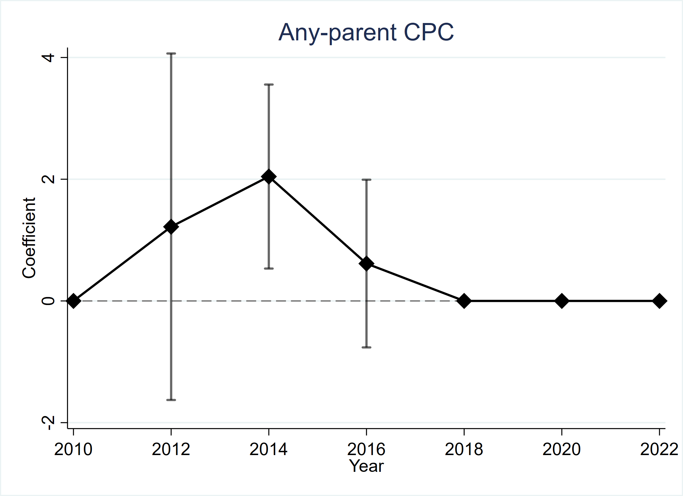

The separate-regression results complement the PCA-based findings in two ways. First, they confirm that the positive association between parental SES and child occupational status is not driven by a single dimension alone. Both occupational and educational resources contribute to intergenerational transmission. Second, they show that the relative importance of fathers and mothers is not identical. In particular, the results point to a comparatively stable role for father’s occupational status and a relatively strong role for mother’s education.

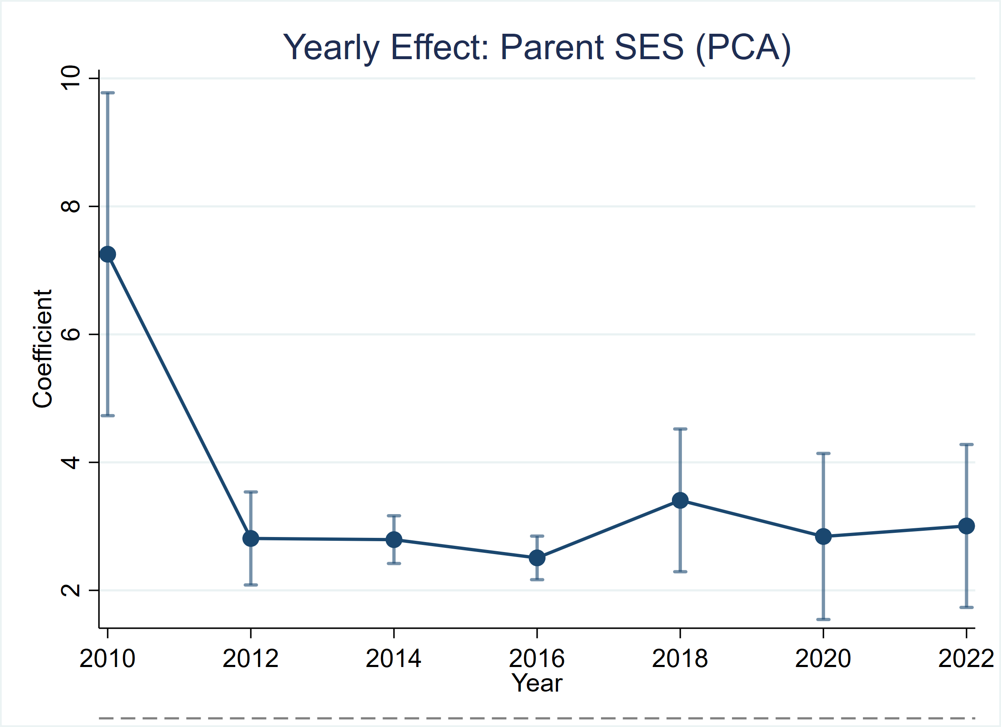

The R-squared values of the decomposed models are slightly higher than those of the PCA-based models in most years, indicating that the separate specification captures somewhat richer variation in family background. However, the PCA index remains useful because it provides a parsimonious summary measure of multidimensional parental advantage and is especially suitable for visualizing year-to-year trends and for quantile regression analysis.

5.3 Quantile Regression

This figure shows how the effect of parental socioeconomic status varies across the lower, middle, and upper parts of the child ISEI distribution over time. Overall, the parent SES effect is strongest at the upper quantile in most years, suggesting that family background matters more for children already located near the top of the occupational distribution. The gap across quantiles narrows after 2010 but remains visible, indicating persistent inequality in intergenerational occupational attainment.

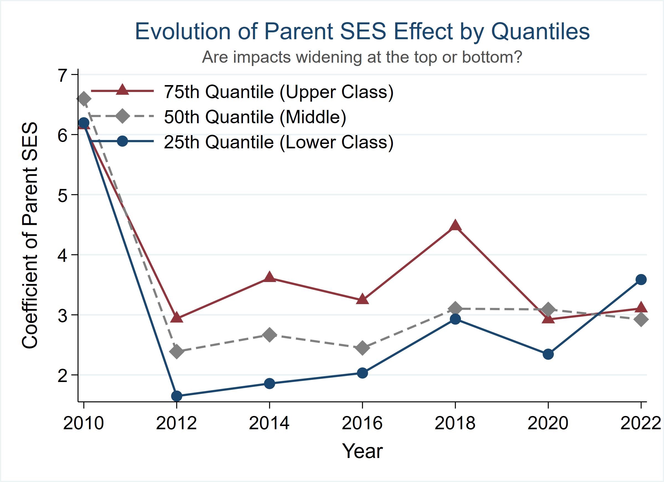

This figure plots the relationship between parent SES and child occupational ISEI in 2022 at different points of the child outcome distribution. The fitted lines show that the association is positive at all quantiles, but the slope is steepest at the lower and median quantiles, while flatter at the top quantile.

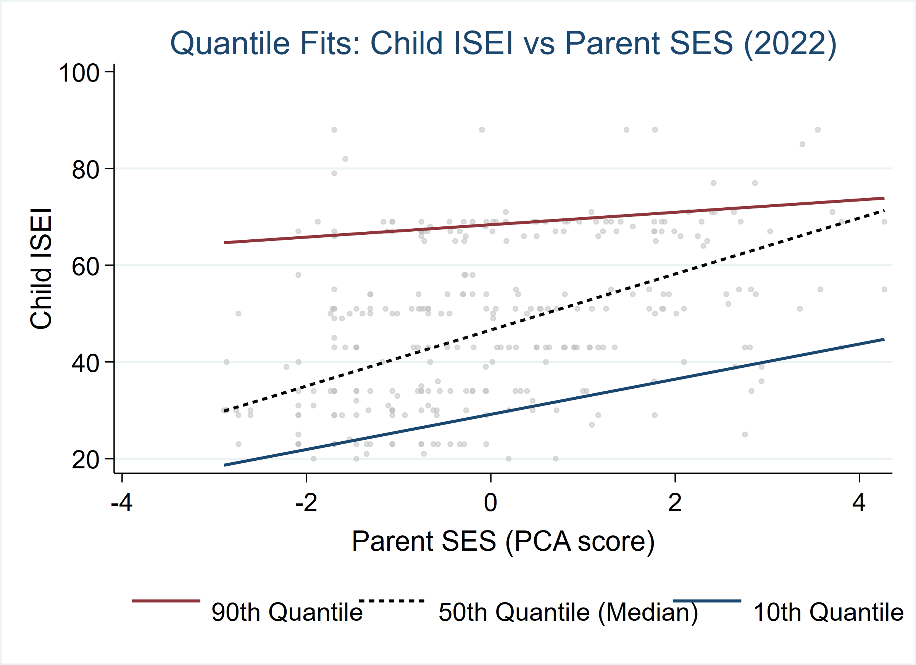

This figure presents quantile regression coefficients of parent SES for each survey year and for the pooled sample. In most years, the estimated effect increases from lower to higher quantiles, indicating stronger intergenerational transmission at the upper end of the child ISEI distribution. Although the strength of the effect fluctuates over time, the overall pattern remains broadly stable: parental SES has a consistently positive influence, especially for children at higher occupational quantiles.

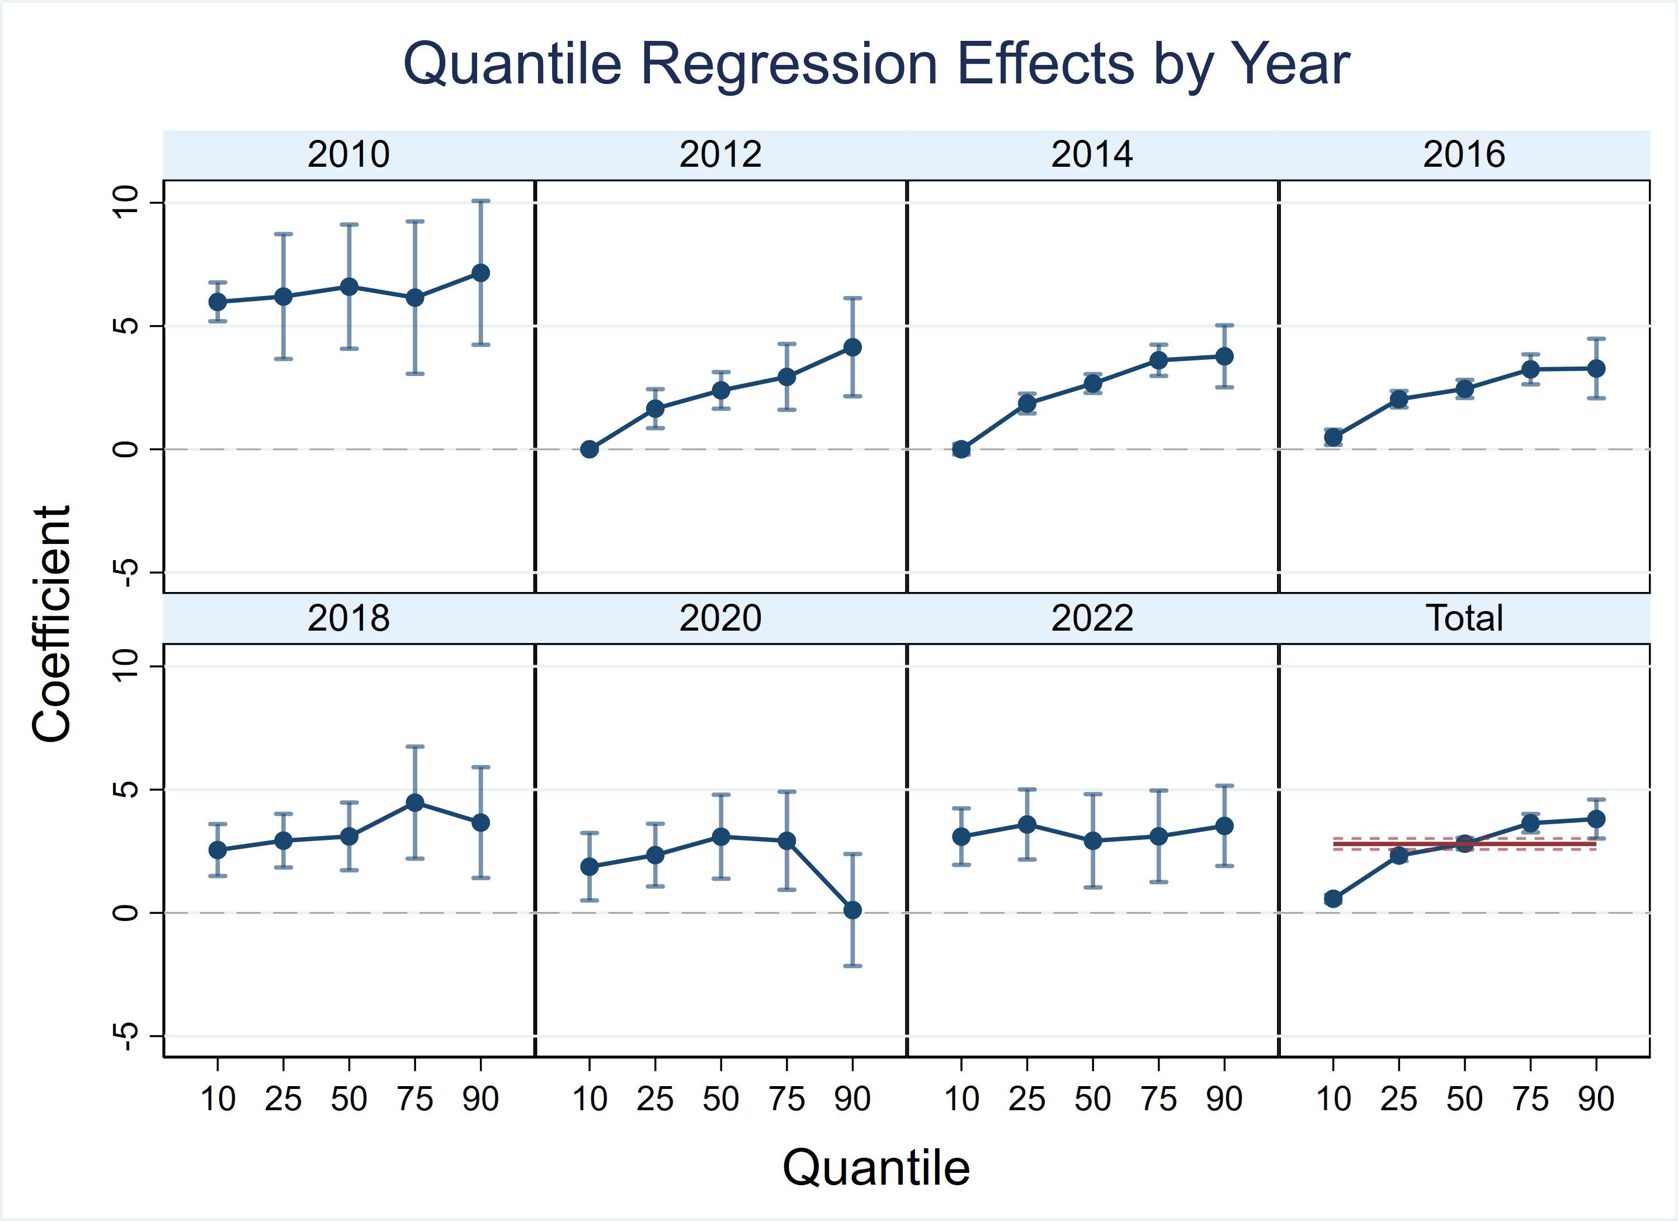

This pooled-sample figure compares quantile regression estimates with the OLS benchmark. The results show a clear upward pattern: the coefficient of parent SES rises steadily from the 10th to the 90th quantile of child ISEI.

Effect of Parent SES on Child ISEI: OLS and Quantile Regressions
 | (1) | (2) | (3) | (4) | (5) | (6)
 | OLS | Q10 | Q25 | Q50 | Q75 | Q90
Parent SES (PCA) | 3.569*** | 0.251*** | 3.068*** | 4.197*** | 4.571*** | 4.106***
 | (0.104) | (0.058) | (0.105) | (0.131) | (0.175) | (0.439)
Controls | Yes | Yes | Yes | Yes | Yes | Yes
Year FE | Yes | Yes | Yes | Yes | Yes | Yes
Province FE | Yes | Yes | Yes | Yes | Yes | Yes
N | 8,487 | 8,487 | 8,487 | 8,487 | 8,487 | 8,487
Dependent variable: Child ISEI. All models include child-level controls. Robust significance: * p<0.10, ** p<0.05, *** p<0.01.
* p < 0.10, ** p < 0.05, *** p < 0.01

Compared with the average OLS effect, parental SES matters less at the bottom of the distribution but substantially more at the top, highlighting important heterogeneity in intergenerational mobility.

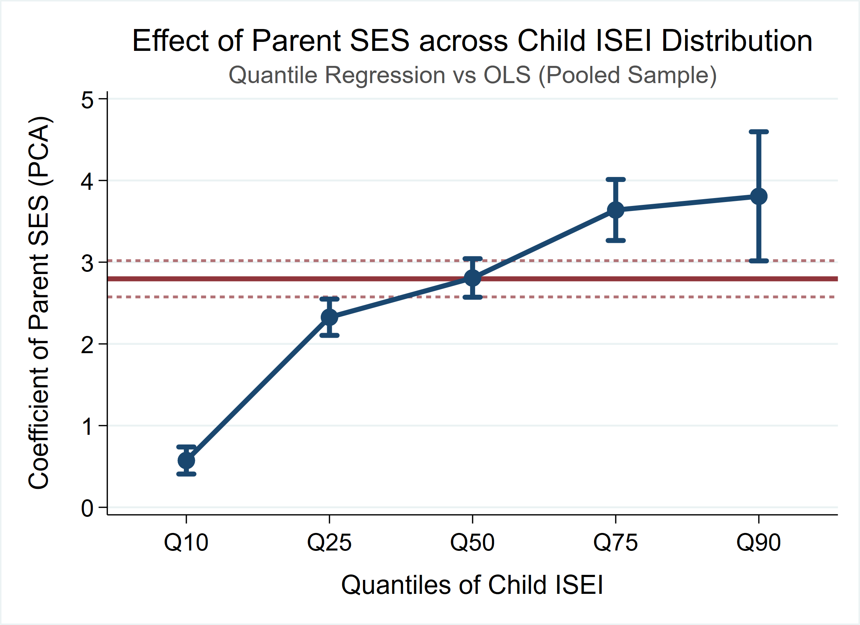
- Robustness Check

- Limitation and Future
  - Challenge and Limitation
- Choice of data structure: panel versus repeated cross-sections.
Although the China Family Panel Studies (CFPS) is designed as a longitudinal survey, the construction of a balanced panel is constrained by sample attrition, inconsistencies in variable availability, and changes in questionnaire design across waves. To preserve sample size and ensure comparability across survey years, this study adopts repeated cross-sectional data from 2014, 2018, and 2022. While this approach improves statistical precision, it limits the ability to examine individual-level dynamics and to make strong causal claims regarding intergenerational mobility.
- Limited comparability across survey years due to macro-level changes
Between 2014 and 2022, China experienced substantial economic growth, labor market restructuring, and evolving social norms related to education and occupational success. Differences in GDP levels and broader economic conditions imply that the meaning and returns of occupational status, as measured by ISEI, may not be fully comparable across years. Therefore, cross-wave differences in estimated coefficients should be interpreted with caution, as they may capture structural and contextual changes rather than purely shifts in intergenerational transmission mechanisms.
- Potential distortion from the COVID-19 pandemic in the 2022 wave.
The 2022 CFPS wave coincides with the period affected by the COVID-19 pandemic, which introduced significant disruptions to employment stability, income opportunities, and occupational mobility. As a result, children's occupational outcomes observed in this wave may reflect short-term shocks rather than long-run socioeconomic positioning, potentially biasing the interpretation of intergenerational effects.
  - Future
- Mechanism analysis through educational mediation.
Building on the established association between parental SES and children's occupational status, subsequent analysis will examine the mediating role of children's educational attainment to analyze the mechanisms through which parental advantages are transmitted across generations.
- Heterogeneous Effects: Quantile Regression
Rather than focusing solely on average effects, quantile regression will be employed to investigate whether parental SES exerts differential influences across the distribution of children’s outcomes. (e.g., comparing the impact on those at the bottom 25% vs. the top 75%).
- Additional heterogeneity by family role and institutional context
Beyond quantile-based heterogeneity, subgroup analyses will be conducted by parental role (father vs. mother) and institutional context (urban vs. rural hukou). These analyses will help clarify whether intergenerational transmission operates differently across family structures and institutional settings.
- Robustness checks
Robustness analyses will primarily focus on replacing the dependent variable with alternative measures of children's occupational outcomes and winsorizing key continuous variables to reduce the influence of extreme values.
- Extended mechanism analysis through additional mediators
Future research will further explore the mechanisms of intergenerational transmission by incorporating parental expectations and children's subjective well-being and mental health as additional mediating variables. This extension aims to examine how parental socioeconomic resources shape not only educational attainment but also psychological outcomes, which in turn influence children’s occupational outcomes.

Literature List

Araki, S. (2025). Reassessing human capital and health capital over the life course. Social Science & Medicine, 381, 118299.
Dubbin, L. A., Chang, J. S., & Shim, J. K. (2013). Cultural health capital and the interactional dynamics of patient-centered care. Social Science & Medicine, 93, 113-120.
Easterlin, R. A., Macdonald, C., & Macunovich, D. J. (1990). How have American baby boomers fared? Earnings and economic well-being of young adults, 1964-1987. Journal of Population Economics, 3(4), 277-290.
Firpo, S. P., Fortin, N. M., & Lemieux, T. (2018). Decomposing wage distributions using recentered influence function regressions. Econometrics, 6(2), 1-40.
Gathmann, C., Jürges, H., & Reinhold, S. (2015). Compulsory schooling reforms, education and mortality in twentieth century Europe. Social Science & Medicine, 127, 74-82.
Hamad, R., Elser, H., Tran, D., Rehkopf, D., & Goodman, S. (2018). How and why studies disagree about the effects of education on health: A systematic review and meta-analysis of studies of compulsory schooling laws. Social Science & Medicine, 212, 168-178.
Xue, X., Cheng, M., & Zhang, W. (2021). Does education really improve health? A meta-analysis. Journal of Economic Surveys, 35(1), 71-105.
Zheng, H., Dirlam, J., Choi, Y., & George, L. (2023). Understanding the health decline of Americans in boomers to millennials. Social Science & Medicine, 337, 116282.
Zheng, H., Lu, Y., & Yao, M. (2024). Emerging health disparities among college graduates: Understanding the health consequences of education-occupation mismatch. Social Science Research, 120, 103015.

